Lebanese American University



COE322 – Logic Design Lab
Logic Design Lab Project - Logic-Controlled Board

Layane Kanso 202304332
Elissa Saad 202301670
Hayfa Siblini 202301917
May 14, 2025
Table of Contents

Table of Figures

Table of Tables

Abstract
This project focuses on the design and implementation of a Logic Controlled Board that responds dynamically to user interaction. The system consists of four toggle switches and four LEDs of corresponding colors. Unlike static logic designs, this system adapts its behavior based on the last switch turned off, activating a unique LED sequence. The design uses finite state machines, combinational logic, and timing circuits, along with special interactive features such as temporary switch disabling and sequence locking. The project was simulated using Quartus software and implemented physically on a breadboard. The final outcome demonstrates how theoretical digital logic concepts can be effectively applied in real-world applications.

Introduction
The Logic Controlled Board project serves as a practical application of the digital logic concepts we studied throughout the semester. It allowed us to design and implement a system that integrates combinational and sequential logic, finite state machines, and timing circuits. The board consists of four switches and four LEDs, but unlike a simple static mapping, it changes behavior based on the last switch turned off. We incorporated interactive features such as sequence-based LED control, a timed reset, switch cap functionality, and a practice mode with a seven segment display. This project enabled us to bridge theory and practice by building a complete, responsive system from design to physical implementation.

Analysis
The Logic Controlled Board is a digital system we designed to control the behavior of four colored LEDs based on how four toggle switches are used. While the system may appear simple at first glance, it functions in a dynamic and logical manner. Instead of having each switch permanently mapped to its corresponding LED, the system detects the last switch that was turned off and reassigns the LED activation sequence accordingly. This design creates the illusion that the board responds intelligently or remembers past actions.
The key idea behind the project is sequence-based control. Each time the system resets, it activates a new LED sequence based on the last switch that was turned off before all switches were turned off. This reset is triggered after a four second delay, allowing the board to determine which switch was deactivated last. Once the reset condition is met, the system enters a new sequence mode, and the LEDs respond based on that configuration until the next reset occurs.
To better understand the logic behind the system, it is important to examine the inputs, outputs, and sequence behavior in detail.
Inputs:
The system relies on the following inputs to function:
- SW1, SW2, SW3, SW4: These are the four toggle switches on the board. They are the only points of direct user interaction. The system continuously monitors their ON and OFF states to determine which LED should be active and when a reset should occur.
- Reset condition: This is a logical condition, not a physical input. When all four switches are OFF and remain so for four seconds, the system resets and determines which sequence to activate based on the last switch that was turned OFF.
Outputs:
The outputs of the system provide immediate visual feedback and assist in debugging during development:
- L1, L2, L3, L4: These four LEDs are each assigned a color (red, green, blue, and yellow). Their behavior is determined by the active sequence, meaning their response to the switches changes depending on which sequence is selected.
- Seven segment display: This optional output was used during development to display the current sequence number (1 to 4). It helped us confirm that the correct sequence was selected after each reset. While useful in practice mode, it can be removed in performance mode for a cleaner appearance.

LED Activation Sequences:
The core functionality of the Logic Controlled Board lies in the way it dynamically changes the LED control pattern based on the last switch turned off. Each switch is assigned to a specific LED activation sequence as follows:
- If SW1 was turned off last:
Sequence 1 is activated
LED order: 1 → 2 → 3 → 4
SW1 controls L1, SW2 controls L2, SW3 controls L3, SW4 controls L4
- If SW2 was turned off last:
Sequence 2 is activated
LED order: 2 → 3 → 4 → 1
SW1 controls L2, SW2 controls L3, SW3 controls L4, SW4 controls L1
- If SW3 was turned off last:
Sequence 3 is activated
LED order: 3 → 4 → 1 → 2
SW1 controls L3, SW2 controls L4, SW3 controls L1, SW4 controls L2
- If SW4 was turned off last:
Sequence 4 is activated
LED order: 4 → 3 → 2 → 1
SW1 controls L4, SW2 controls L3, SW3 controls L2, SW4 controls L1
These sequences ensure that the board does not behave in a fixed or predictable way. Instead, it responds to the user's most recent actions and reorganizes itself accordingly. This gives the impression of a smart system, although it is fully based on logic and memory tracking.
The design was not built using formal truth tables or state diagrams. Instead, we approached the system by thinking through the logic step by step. We planned the sequences manually, tested the responses, and built the logic directly into the circuit. This method allowed us to stay focused on functionality and keep the design intuitive and reliable.
Overall, the Logic Controlled Board behaves as a responsive digital system that adapts to how the user interacts with it. The LED control logic is clear and consistent, and the dynamic behavior is managed entirely through a combination of switch states, memory, and timed resets. This analysis outlines the thought process and structure that made the system function as intended.

A. Project Overview
This project implements a multi-functional digital circuit system that dynamically maps switch inputs to LEDs, supports multiple programmable sequences, and maintains internal state through register-based memory. The system is modular, scalable, and designed to operate through synchronized clock pulses, with dedicated logic for initialization and state locking.
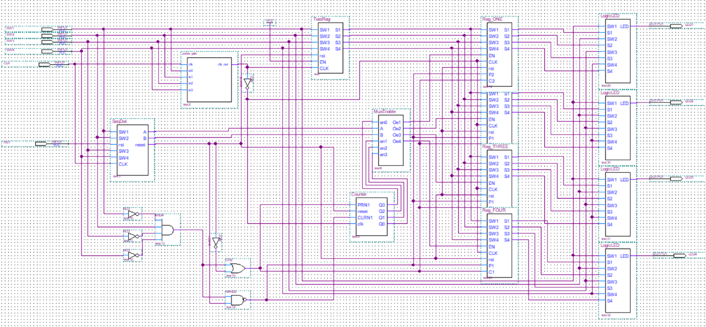
Figure 1 – Overall Logic Circuit

Part 1: LogicLED - Initial Sequence Mapping
We began by creating Sequence 1, which turns on LED1, then LED2, LED3, and finally LED4, regardless of which switches (SW1 to SW4) are used. A key requirement was that each switch, when used to activate an LED, would also be responsible for turning it off. This mapping was critical to ensure intuitive interaction between the hardware components.
To implement this, we defined a 4-bit switch encoding: S1S2S3S4. We adopted a convention where a switch in the ON state is represented by '0' and in the OFF state by '1'. For example:
- SW1 ON: 0111
- SW2 ON: 1011
- SW3 ON: 1101
- SW4 ON: 1110
This encoding ensures the detection of an activated switch using logic that aligns with the behavior of the logic gates.
In the LogicLED block, the output for LED1 is computed as:
$$LED1 = (S1 + SW1)(S2 + SW2)(S3 + SW3)(S4 + SW4)$$
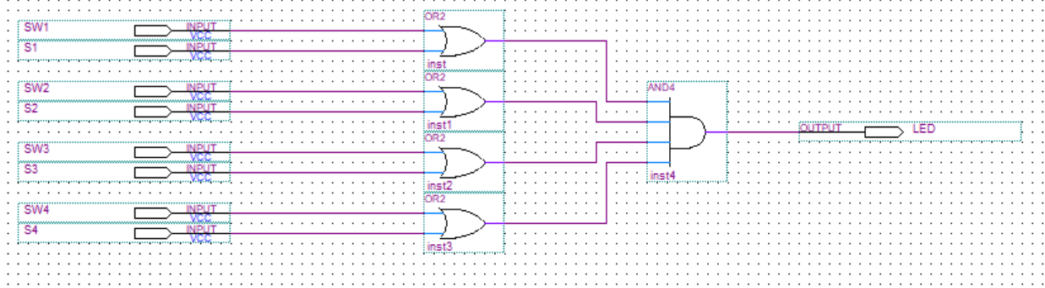
Figure 2 - Circuit inside of LogicLED blocks
Example: If we activate SW3 (S1S2S3S4 = 1101):
- LED1 = (1 + SW1)(1 + SW2)(0 + SW3)(1 + SW4)
- Simplifying: LED1 = 1 * 1 * SW3 * 1 = SW3
Thus, LED1 is directly controlled by SW3. Turning SW3 on turns the LED on, and turning it off switches it off. This achieved the required switch-to-LED mapping. This also goes for the other 3 leds.

Part 2: Registers - Storing LED States
To preserve the encoded switch bits, we used two 7474 dual D-type flip-flops (totaling 4 bits). These flip-flops store the S1S2S3S4 state and feed their outputs into the LogicLED block.
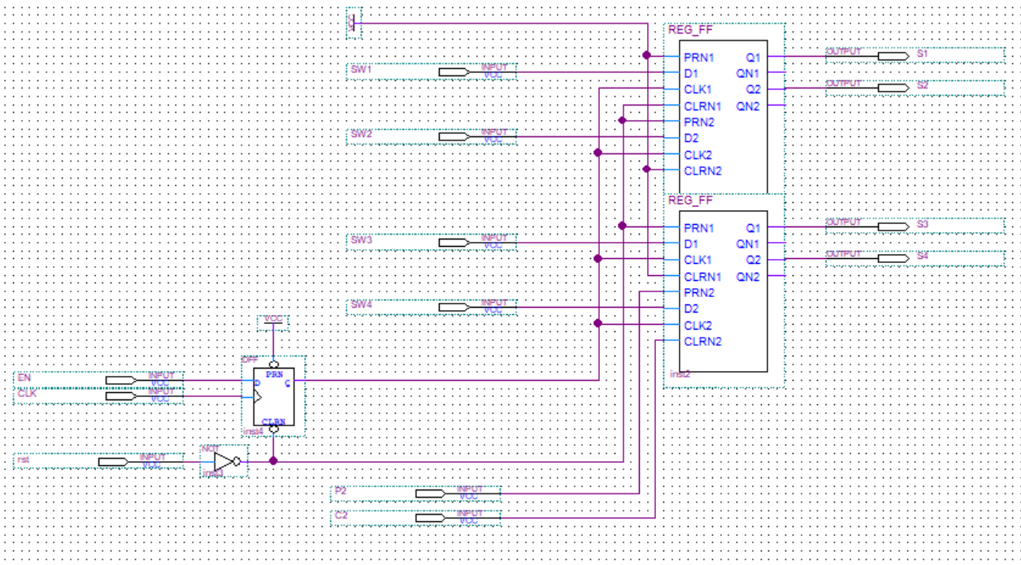
Figure 3 - Circuit inside of Reg Blocks
Inputs to the registers are the encoded bits, which we explain in Part 3. The registers are clocked by the pulse generator, but due to timing issues observed during simulation, we introduced an additional D flip-flop between the pulse generator and the 7474s to introduce a controlled delay.
Presets and clears of the 7474s are reserved for handling the locked state, which we discuss in a later section.

Part 3: TestReg - Encoding the Switch States
To generate the S1S2S3S4 encoded bits, we created the TestReg block. This module uses two 7474 flip-flops in cascade, where the output of the first is NXORed with the output of the second. This allows us to detect changes in switch states.
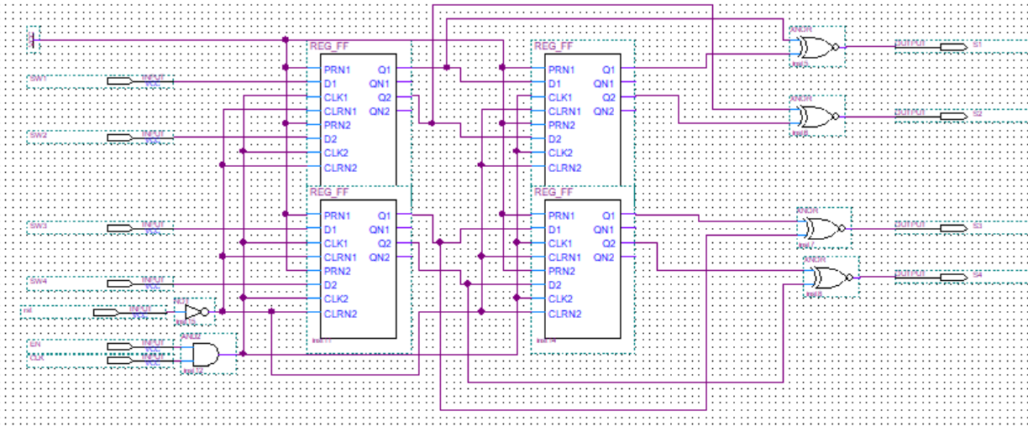
Figure 4 - Circuit inside of TestReg Block
Example:
- Initial switch state: 0000 → No switches ON
- After turning on SW1: 1000 → Desired output: 0111
- After turning on SW3 next: 1010 → Desired output: 1101
This behavior mirrors the NXOR gate truth table, where the output is ‘1’ when both inputs are the same and ‘0’ otherwise. We NXOR the previous and current switch states to detect which switch was activated.
All presets are tied to logic '1', and clears are tied to a global reset signal (_Reset), which plays a critical role and is discussed later.

Part 4: Shift Register - Sequencing LED Activation
With mapping established, we next required a mechanism to sequence the register activations—specifically to follow the order 1 → 2 → 3 → 4.
We constructed a 4-bit shift register using two 7474s with an initial state of 1000. The D input of the first flip-flop is tied to ground, so each clock pulse shifts the ‘1’ rightward while filling with ‘0’s from the left:
Pattern: 1000 → 0100 → 0010 → 0001 → 0000
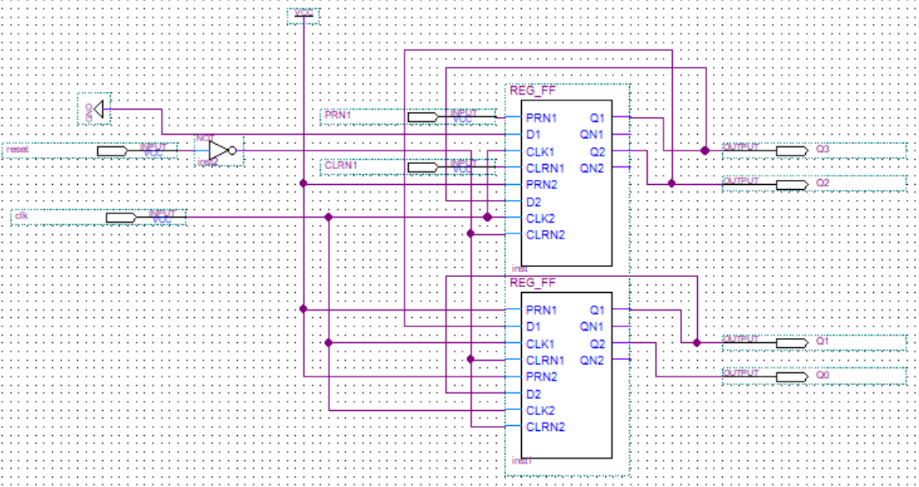
Figure 5 - Circuit inside of Counter block
This behavior enables the sequential activation of the LEDs in Sequence 1 and ensures a controlled progression.

Part 5: Sequence Detector - Identifying Active Sequence
To support multiple sequences, we needed a way to determine which sequence was active. This was based on identifying which switch was turned OFF last. We reused the TestReg logic but inverted the input switches using a 7404 inverter chip. This allowed us to detect the last switch-off event.
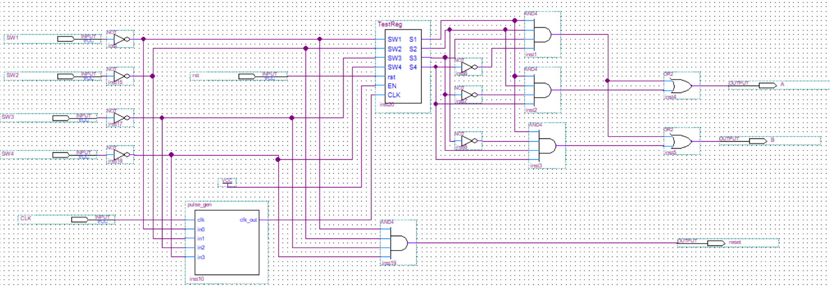
Figure 6 - Circuit inside of SeqDet Block
Example:
- If SW1 is last off: S1S2S3S4 = 0111
We defined the following table to decode the sequence:
Table 1 - Table to encode our sequence bits
S1 | S2 | S3 | S4 | A | B
0 | 1 | 1 | 1 | 0 | 0
1 | 0 | 1 | 1 | 0 | 1
1 | 1 | 0 | 1 | 1 | 0
1 | 1 | 1 | 0 | 1 | 1
Using sum of minterms, we derived:
- $A = S1·S2·S3'·S4 + S1·S2·S3·S4'$
- $B = S1·S2·S3·S4' + S1·S2'·S3·S4$
The outputs A and B represent a 2-bit sequence code and are connected to a BCD-to-7 segment display (common anode) to indicate the current sequence.
Additionally, the sequence detector block implements the global reset logic for the entire circuit. Rather than relying on an external push-button reset, the system is designed to reset itself when all input switches are turned off, i.e., when the input pattern is S1'S2'S3'S4'. This condition triggers a reset signal that propagates to all major modules—counters, registers, detectors—ensuring a clean return to the initial state. This design choice enhances user experience and simplifies testing by embedding reset behavior directly into the system logic.

Part 6: MUXenable - Reconfiguring Register Enables Based on Sequence
To allow different sequences to be executed, we developed the MUXenable block. It dynamically rearranges the register enables based on the current sequence identified by AB.
We defined enables for four cycles. For each cycle, enable logic expressions are as follows:
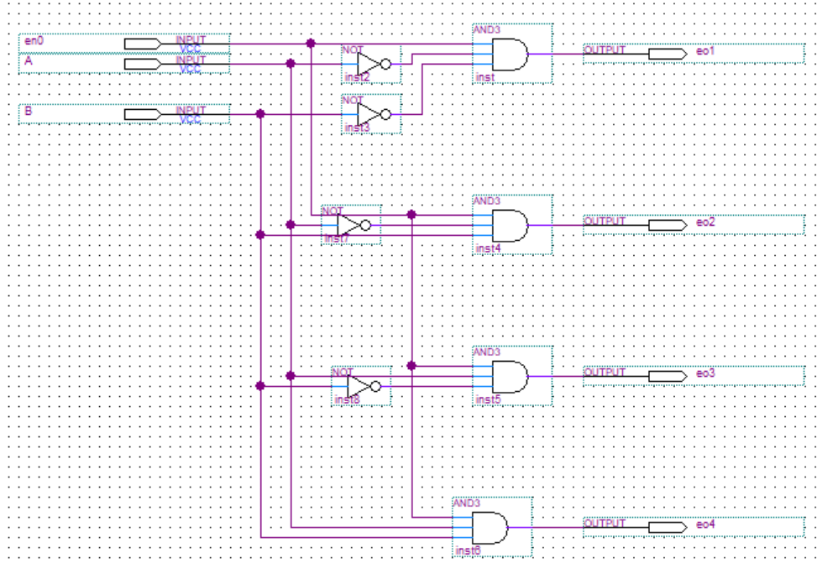
Figure 7 - Circuit inside of NewEnable Block
Cycle 1:
- e01 = en0·A'·B' → e1
- e02 = en0·A'·B → e2
- e03 = en0·A·B' → e3
- e04 = en0·A·B → e4
Cycle 2:
- e01 = en1·A'·B' → e2
- e02 = en1·A'·B → e3
- e03 = en1·A·B' → e4
- e04 = en1·A·B → e1

Cycle 3:
- e01 = en2·A'·B' → e3
- e02 = en2·A'·B → e4
- e03 = en2·A·B' → e1
- e04 = en2·A·B → e2
Cycle 4:
- e01 = en3·A'·B' → e4
- e02 = en3·A'·B → e1
- e03 = en3·A·B' → e2
- e04 = en3·A·B → e3
Each group of four outputs from the MUXenable block is combined using 4-input OR gates to produce the final register enable signals: e1, e2, e3, e4.
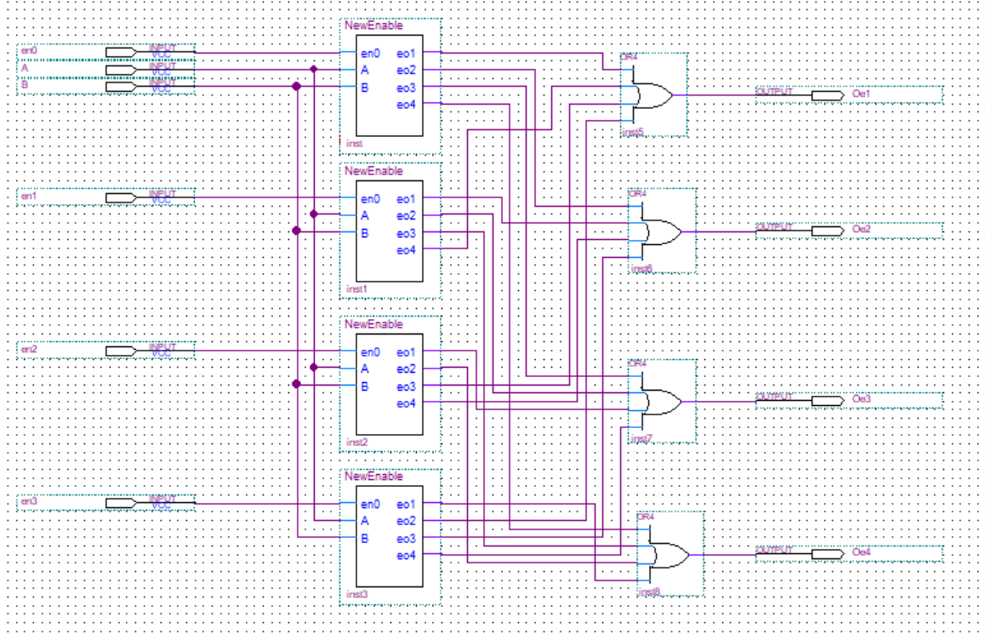
Figure 8 - Circuit inside of MUXEnable Block
This generalized enable logic allows us to scale the system from supporting just Sequence 1 to all four sequences, maintaining proper activation order based on the last switch-off.

Part 7 clock

Part 8 detect and preset

Part 9: Simulation and Results
To validate the functionality of our complete design, we conducted a detailed simulation using ModelSim. The simulation was run step by step to observe how the system behaves under various input sequences. Below is a breakdown of the observed behavior:
- Initial Reset and Default State Behavior
At the beginning of the simulation, the reset signal was asserted while all switches were turned off. As expected, all LEDs remained off, confirming that the global reset logic and initial state were functioning correctly.
Once the reset signal was deasserted, the system transitioned into the default case, where each switch is mapped to a specific LED as follows:
- Turning on Switch 3 → LED 1 turned ON
- Turning on Switch 4 → LED 2 turned ON
- Turning on Switch 2 → LED 3 turned ON
- Turning on Switch 1 → LED 4 turned ON
Subsequently, we tested the deactivation logic by turning off the switches one by one:
- Switch 2 turned OFF → LED 3 turned OFF
- Switch 4 turned OFF → LED 2 turned OFF
- Switch 3 turned OFF → LED 1 turned OFF
- Switch 2 turned ON again → LED 3 turned ON
- Switch 1 turned OFF → LED 4 turned OFF
- Switch 2 turned OFF → LED 3 turned OFF
These results clearly verify that each switch correctly controls its corresponding LED, and the system maintains consistent behavior across toggles.
- Sequence Detection Behavior
At this point, since the last switch turned off was Switch 2, the sequence detector recognized this and transitioned the system into Sequence 2, as intended. Without pressing the reset, we continued:
- Turning on Switch 1 → LED 2 turned ON
- Turning on Switch 2 → LED 3 turned ON
- Turning on Switch 3 → LED 4 turned ON
- Turning on Switch 4 → LED 1 turned ON
This confirmed the functionality of the sequence detector in correctly identifying the last switch turned off and shifting the output LED mapping accordingly.
- Locked State Verification
To test the behavior after a reset, we jumped ahead in the simulation and asserted the reset signal again, this time while Switch 2 was ON. After deasserting the reset:
- Switch 4 turned ON → LED 4 turned ON
- Switch 2 turned OFF → LED 2 turned OFF
- Switch 1 turned ON → LED 1 turned ON
- Switch 3 turned ON → LED 3 turned ON
These results demonstrate that the system successfully returned to a locked state, in which each switch is mapped directly to its corresponding LED (i.e., Switch i → LED i). The consistent LED control confirms the reliability of our global reset logic and final state behavior.

B. Designs we didn’t use
One of the most important challenges in this project was designing a system that could correctly identify which switch was turned off last and use that information to activate the corresponding LED sequence. Throughout the development process, we explored several different approaches before arriving at a final solution. Each attempt helped us better understand the behavior of the system and guided us closer to a cleaner and more efficient design.
Initial Attempt: D Flip Flop-Based Detection
Our first idea was to detect falling edges in the switches by using D flip flops. The logic behind this approach was to store the current and previous states of each switch. When a switch transitioned from ON to OFF, the system would detect that falling edge and generate a high signal, indicating that this switch was the last one turned off.
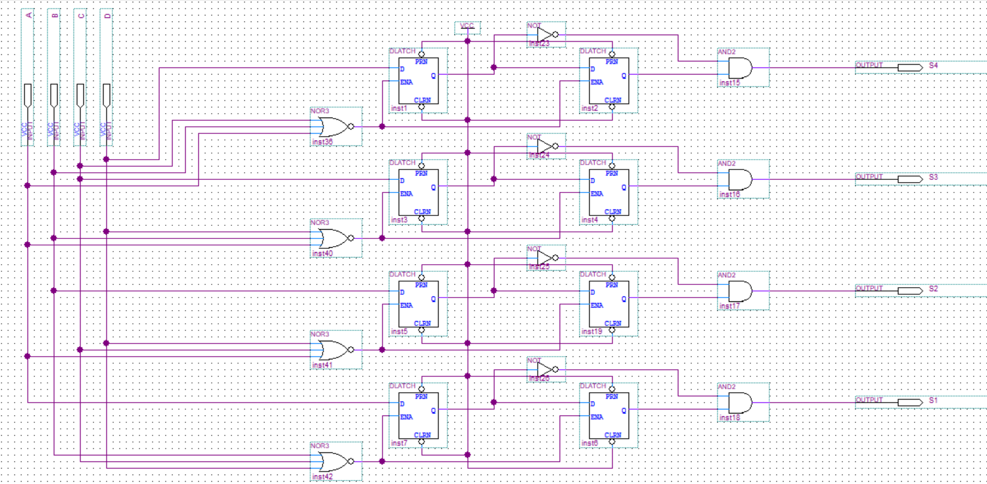
Figure 1 - Sequence Detector Circuit Using D Flip Flops (Without SR Latches)
To test this logic, we ran simulations in Quartus. The results showed that the output signal did detect the transition correctly, but only for a very short period. The signal would go high briefly and then immediately drop back to zero. This behavior was not ideal for our system, because we needed the output to remain high and stable until the system was ready to reset and switch to the appropriate LED sequence.
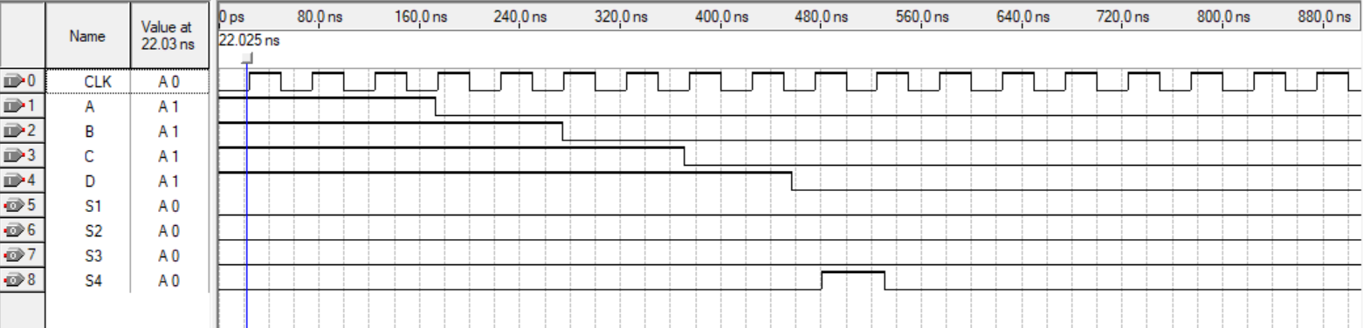
Figure 2 - Simulation of Circuit Without SR Latches
To fix this problem, we modified the design by adding SR latches after the detection logic. The SR latch captured the brief high pulse and held it as a stable output until it was explicitly cleared. This ensured that once a switch was turned off, the corresponding output would remain high and allow the system to detect the correct sequence reliably.
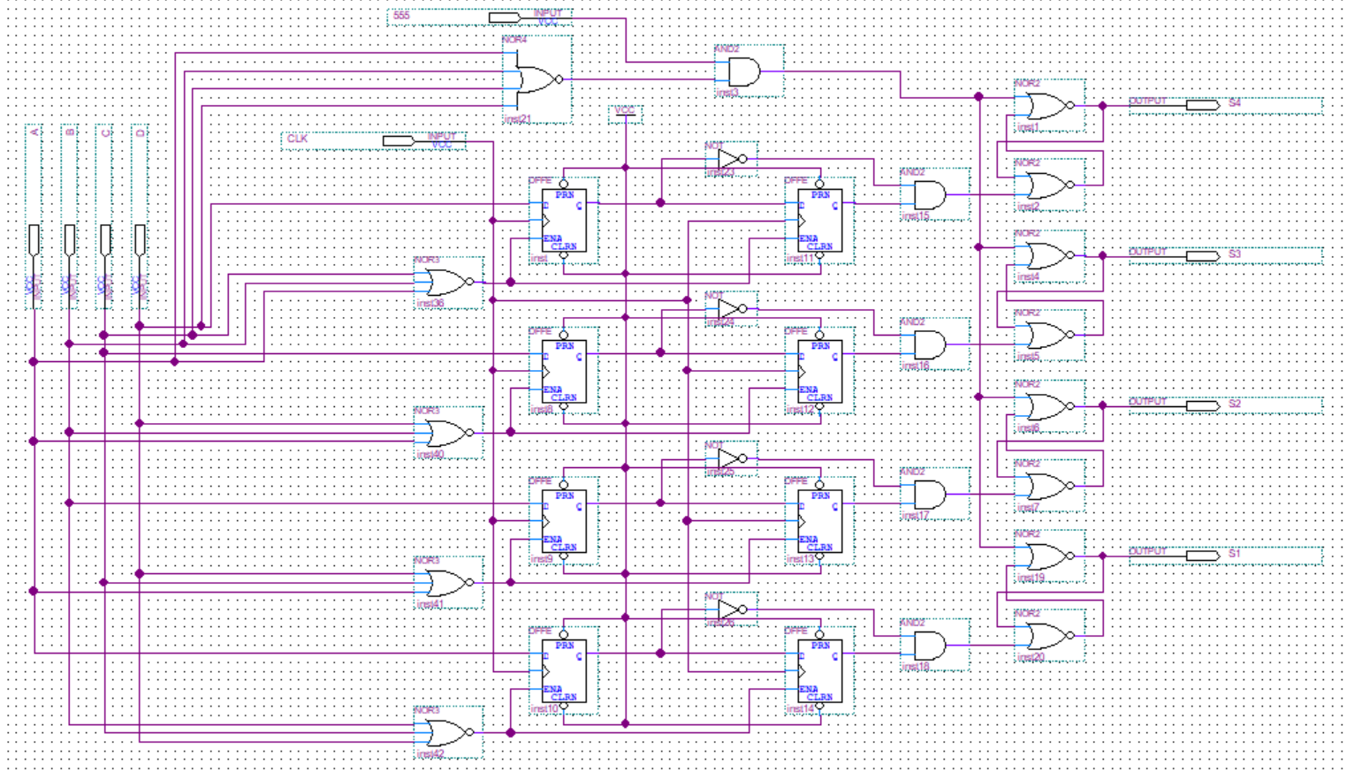
Figure 3 - Modified Sequence Detector Circuit Using SR Latches
While this solution worked correctly, it significantly increased the complexity of the circuit. The number of gates and wires made the design bulky and difficult to manage. We realized that for our project goals, this approach was more complicated than necessary and not practical for implementation on a small breadboard setup.
At this point, instead of moving to a simplified direct logic method, we decided to try another formal approach. We attempted to model the system as a finite state machine, using state diagrams and state tables to determine the correct sequence logic.

Second Attempt: State Diagram and Table Method
After moving away from the latch-based design, we tried modeling the system using a finite state machine. Our idea was to define states based on which switches were ON at a given time and use those states to generate the correct output sequence.
We defined the following key states:
- A general state where more than two switches are ON, represented as 101
- A state for SW1 ON, represented as 001
- A state for SW2 ON, represented as 010
- A state for SW3 ON, represented as 011
- A state for SW4 ON, represented as 100
- A special state where all switches are OFF, represented as 000
Our inputs were the four switches:
- SW1, SW2, SW3, SW4
The outputs were as follows:
- Sequence 1: 00
- Sequence 2: 01
- Sequence 3: 10
- Sequence 4: 11
- Valid output (V): 1 when the input is valid, 0 otherwise
We used this information to draw a full state diagram showing all the transitions and output values.
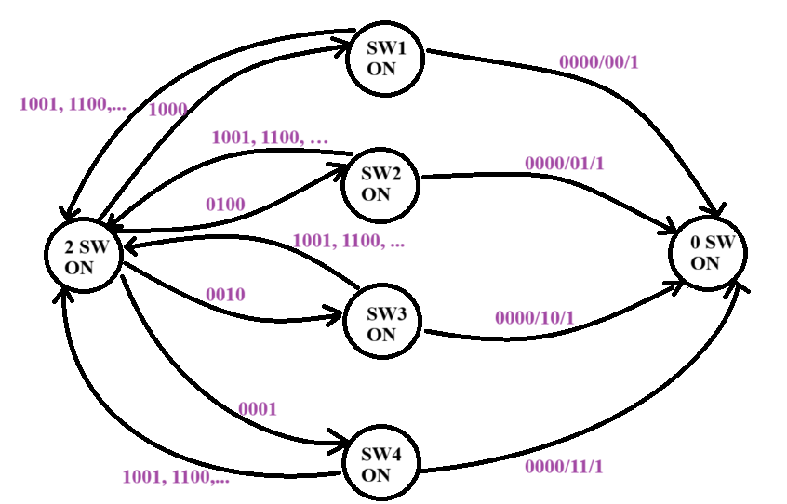
Figure 4 - State Diagram for FSM-Based Sequence Detector
Based on the diagram, we constructed a state table listing all current states, inputs, outputs, and transitions.
Table 1 - State Table for FSM-Based Sequence Detector
Inputs |  |  |  | Next State |  |  | Outputs
SW1 | SW2 | SW3 | SW4 | E' | H' | L' | SQ1 | SQ2 | V
0 | 0 | 0 | 0 | 0 | 0 | 0 | X | X | 1
0 | 0 | 0 | 1 | 1 | 0 | 0 | X | X | 0
0 | 0 | 1 | 0 | 0 | 1 | 1 | X | X | 0
0 | 0 | 1 | 1 | 1 | 0 | 1 | X | X | 0
0 | 1 | 0 | 0 | 0 | 1 | 0 | X | X | 0
0 | 1 | 0 | 1 | 1 | 0 | 1 | X | X | 0
0 | 1 | 1 | 0 | 1 | 0 | 1 | X | X | 0
1 | 0 | 0 | 0 | 0 | 0 | 1 | X | X | 0
1 | 0 | 0 | 1 | 1 | 0 | 1 | X | X | 0
1 | 0 | 1 | 0 | 1 | 0 | 1 | X | X | 0
1 | 1 | 0 | 0 | 1 | 0 | 1 | X | X | 0
0 | 0 | 0 | 0 | 0 | 0 | 0 | 0 | 0 | 1
0 | 0 | 0 | 1 | 1 | 0 | 0 | X | X | 0
0 | 0 | 1 | 0 | 0 | 1 | 1 | X | X | 0
0 | 0 | 1 | 1 | 1 | 0 | 1 | X | X | 0
0 | 1 | 0 | 0 | 0 | 1 | 0 | X | X | 0
0 | 1 | 0 | 1 | 1 | 0 | 1 | X | X | 0
0 | 1 | 1 | 0 | 1 | 0 | 1 | X | X | 0
1 | 0 | 0 | 0 | 0 | 0 | 1 | X | X | 0
1 | 0 | 0 | 1 | 1 | 0 | 1 | X | X | 0
1 | 0 | 1 | 0 | 1 | 0 | 1 | X | X | 0
1 | 1 | 0 | 0 | 1 | 0 | 1 | X | X | 0
0 | 0 | 0 | 0 | 0 | 0 | 0 | 0 | 1 | 1
0 | 0 | 0 | 1 | 1 | 0 | 0 | X | X | 0
0 | 0 | 1 | 0 | 0 | 1 | 1 | X | X | 0
0 | 0 | 1 | 1 | 1 | 0 | 1 | X | X | 0
0 | 1 | 0 | 0 | 0 | 1 | 0 | X | X | 0
0 | 1 | 0 | 1 | 1 | 0 | 1 | X | X | 0
0 | 1 | 1 | 0 | 1 | 0 | 1 | X | X | 0
1 | 0 | 0 | 0 | 0 | 0 | 1 | X | X | 0
1 | 0 | 0 | 1 | 1 | 0 | 1 | X | X | 0
1 | 0 | 1 | 0 | 1 | 0 | 1 | X | X | 0
1 | 1 | 0 | 0 | 1 | 0 | 1 | X | X | 0
0 | 0 | 0 | 0 | 0 | 0 | 0 | 1 | 0 | 1
0 | 0 | 0 | 1 | 1 | 0 | 0 | X | X | 0
0 | 0 | 1 | 0 | 0 | 1 | 1 | X | X | 0
0 | 0 | 1 | 1 | 1 | 0 | 1 | X | X | 0
0 | 1 | 0 | 0 | 0 | 1 | 0 | X | X | 0
0 | 1 | 0 | 1 | 1 | 0 | 1 | X | X | 0
0 | 1 | 1 | 0 | 1 | 0 | 1 | X | X | 0
1 | 0 | 0 | 0 | 0 | 0 | 1 | X | X | 0
1 | 0 | 0 | 1 | 1 | 0 | 1 | X | X | 0
1 | 0 | 1 | 0 | 1 | 0 | 1 | X | X | 0
0 | 0 | 0 | 0 | 0 | 0 | 0 | 1 | 1 | 1
0 | 0 | 0 | 1 | 1 | 0 | 0 | X | X | 0
0 | 0 | 1 | 0 | 0 | 1 | 1 | X | X | 0
0 | 0 | 1 | 1 | 1 | 0 | 1 | X | X | 0
0 | 1 | 0 | 0 | 0 | 1 | 0 | X | X | 0
0 | 1 | 0 | 1 | 1 | 0 | 1 | X | X | 0
0 | 1 | 1 | 0 | 1 | 0 | 1 | X | X | 0
0 | 1 | 1 | 1 | 1 | 0 | 1 | X | X | 0
1 | 0 | 0 | 0 | 0 | 0 | 1 | X | X | 0
1 | 0 | 0 | 1 | 1 | 0 | 1 | X | X | 0
1 | 0 | 1 | 0 | 1 | 0 | 1 | X | X | 0
1 | 1 | 0 | 0 | 1 | 0 | 1 | X | X | 0
0 | 0 | 0 | 1 | 1 | 0 | 0 | X | X | 0
0 | 0 | 1 | 0 | 0 | 1 | 1 | X | X | 0
0 | 0 | 1 | 1 | 1 | 0 | 1 | X | X | 0
0 | 1 | 0 | 0 | 0 | 1 | 0 | X | X | 0
0 | 1 | 0 | 1 | 1 | 0 | 1 | X | X | 0
0 | 1 | 1 | 0 | 1 | 0 | 1 | X | X | 0
1 | 0 | 0 | 0 | 0 | 0 | 1 | X | X | 0
1 | 0 | 0 | 1 | 1 | 0 | 1 | X | X | 0
1 | 0 | 1 | 0 | 1 | 0 | 1 | X | X | 0
1 | 1 | 0 | 0 | 1 | 0 | 1 | X | X | 0
1 | 1 | 0 | 1 | 1 | 0 | 1 | X | X | 0

After completing the table, we began deriving Boolean equations for the output logic. However, when simplifying the expressions for selecting the correct sequence, we realized the equations were becoming far too long and complex. Even after removing unnecessary states and grouping similar conditions, the results were not practical for hardware implementation.
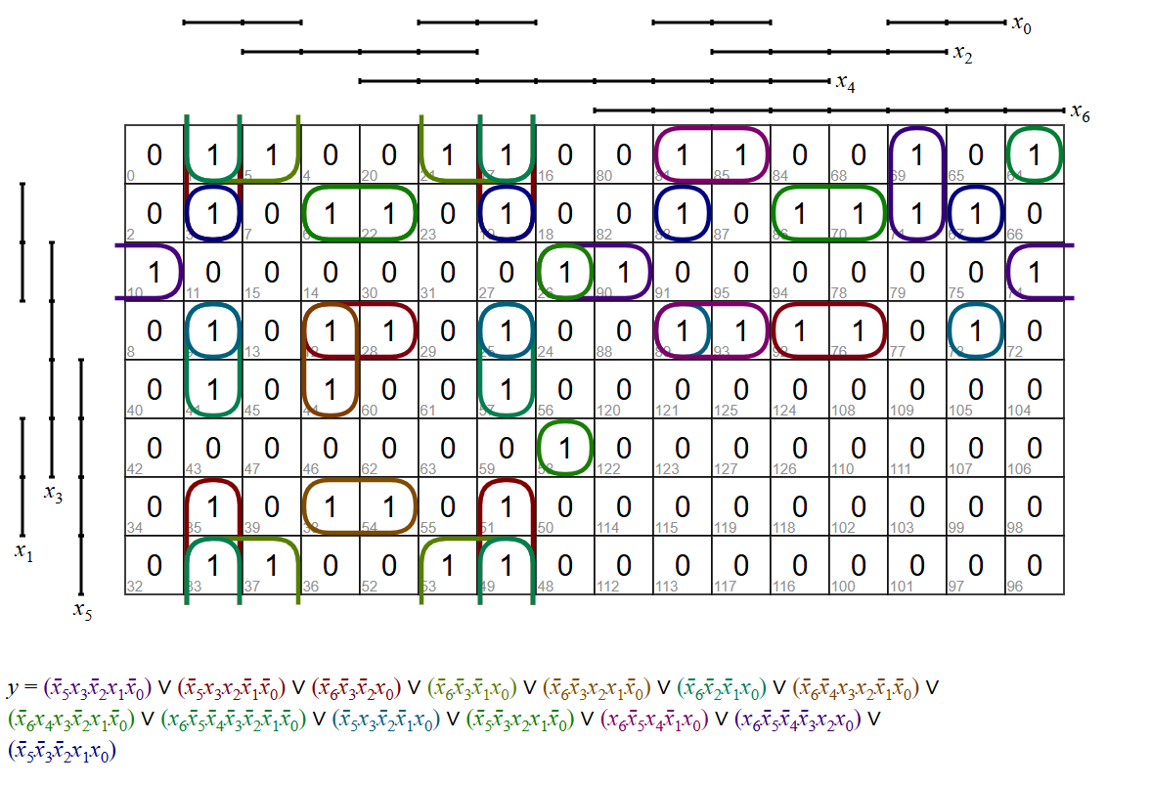
Figure 5 - Example of a Long Output Equation
This complexity suggested that something in our logic or state assignment was incorrect, or at the very least overly complicated. It became clear that this method, while organized, was not suitable for our specific project. The effort required to build and debug such a circuit would have outweighed the benefit of using a structured state machine.
For that reason, we decided not to move forward with the FSM-based design either. While this method helped us explore the problem from a formal perspective and gave us deeper insight into system behavior, it did not meet our need for a simple, reliable, and efficient design.

Conclusion
The Logic Controlled Board project allowed us to apply the digital logic concepts we learned throughout the semester in a practical and hands-on setting. We designed a system that uses finite state machines, sequential logic, and timing circuits to create dynamic behavior based on user interaction. The board responds to the last switch turned off and adjusts the LED activation sequence accordingly, which creates the illusion of intelligent control. Our approach to the design was based on logical thinking and analysis rather than formal truth tables or state diagrams. We focused on understanding how each part of the system should behave and built our solution step by step using clear reasoning. This method allowed us to simplify the design and focus on functionality while still meeting the project requirements. Through this project, we were able to connect theoretical knowledge to real circuit implementation. We gained experience in using Quartus for simulation, assembling the hardware on a breadboard, and solving problems that came up during testing. The project helped us strengthen our understanding of digital systems and gave us the confidence to approach more complex designs in the future.

